Chairman’s Statement

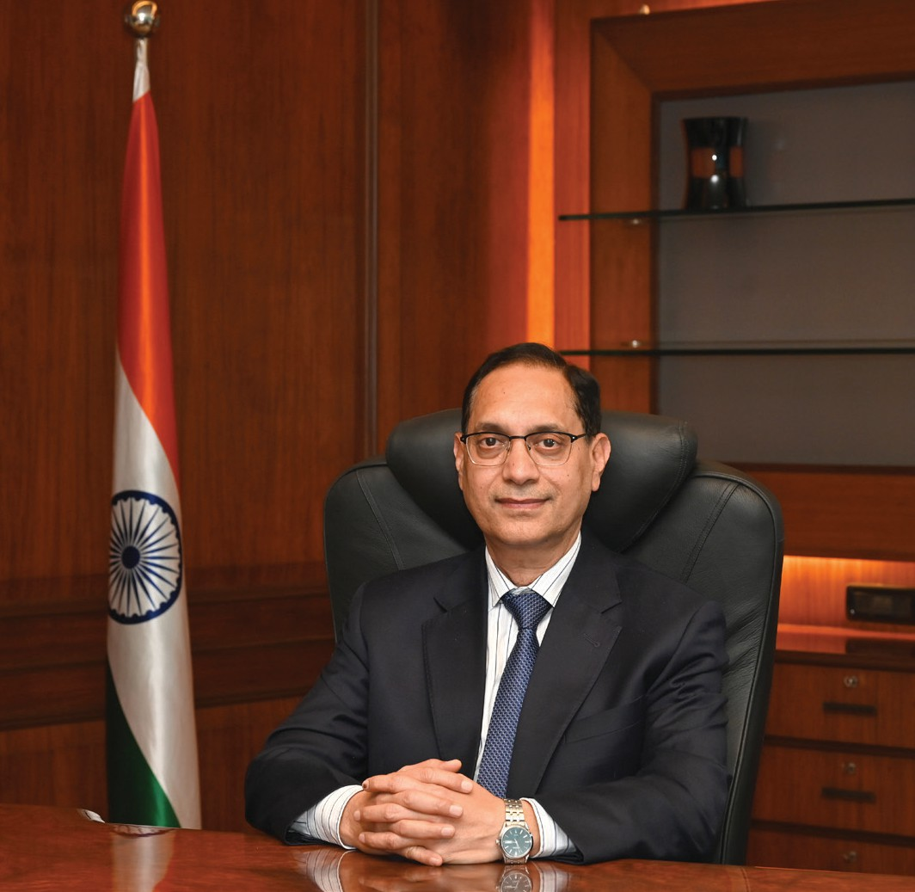

he financial year 2025-26 was a year of resilience for Indian securities markets. The year, one of
T
the most eventful and challenging in recent times, showed that amid myriad uncertainties in the global environment - marked by geopolitical conflicts, trade wars, transformative technologies, volatility in asset prices and portfolio flows - our markets possess the institutional resilience to remain well-functioning and trustworthy. The true strength of a well regulated market lies not in the absence of volatility, but in its ability to ensure orderly price discovery, safeguard investor interests and facilitate efficient capital formation. Measured against these parameters, India’s capital markets continued to deepen in both scale and sophistication during the year. As we progress towards the goal of Viksit Bharat 2047, the Indian securities market serves as a vital engine of national progress, anchored by four enduring principles: trust, transparency, teamwork and technology.
In pursuit of this vision, our regulatory philosophy has transitioned this year towards resilience by design - embedding structural integrity through optimum regulation and pioneering AI-driven oversight. By modernizing legacy frameworks and
deploying sophisticated supervisory technology, SEBI has not only simplified the path for market participants but has also fortified the trust that is the bedrock of our financial future. This year’s reforms represent a strategic leap from building market access to ensuring market endurance in an era of rapid technological and geopolitical evolution.
Capital Formation: Financing the National Vision
India’s ambition of becoming a developed economy by 2047 places extraordinary demands on its capital formation ecosystem. The investments required across infrastructure, energy transition and manufacturing capacity cannot be met through the banking system alone. Consequently, our policy focus this year has been to ensure that the corporate bond market, the equity market and the alternative investment ecosystem serve as indispensable complements to traditional financing.
The primary equity market demonstrated continued dynamism, with India ranking first globally in the number of IPOs and third in terms of fund raised. To sustain this momentum, we restructured the minimum public offer framework, calibrating public float requirements to issue-size. By extending the timeline for the largest issuers to achieve 25 per cent minimum public shareholding to ten years, we have ensured that large-scale enterprises can access public capital, without facing challenges of regular dilution post listing. Similarly, by allowing founders of new-age companies to retain ESOPs granted prior to an IPO, we have maintained the alignment of long-term incentives while preserving transparency for public shareholders.
In the alternative investment space, AIFs have become a structurally important component of India’s capital market. A new category, accredited investors - only schemes was introduced to provide additional relaxations and operational flexibilities. The minimum investment threshold for large value funds was reduced from ₹70 crore to ₹25 crore. Category I & II AIFs were permitted to offer Co-

investment schemes to facilitate AIFs and investors to co-invest. These measures are designed to direct capital toward start-ups and strategic sectors under a lighter, yet robust, regulatory regime. REITs and InvITs have matured from nascent instruments into significant infrastructure financing channels. Furthermore, the reclassification of REITs as equity related instruments for any investment made by Mutual Funds and SIFs, is a landmark shift that should increase liquidity and broaden the investor base for these instruments.
India’s corporate bond market has made measurable progress in recent years. On the issuance side, SEBI launched the inaugural Pan-India Bond Issuer Outreach Programme, a consultative initiative designed to hear directly from issuers about the practical barriers to bond market access. To broaden the retail investor base in debt, issuers were permitted to offer incentives such as additional interest or price discounts, to retail investors and senior citizens. The Electronic Book Provider (EBP) mechanism is now mandatory for the debt issuances of Rs. 20 crore or above – bringing higher fundraising onto a common, transparent and standardized marketplace leading to fair & efficient price discovery and enhanced transparency.
Simultaneously, urban local bodies were encouraged to access market-based funding for civic infrastructure. The municipal bond market witnessed 14 issuances raising ₹1,756 crore, supported by targeted municipal bond outreach programmes in cities like Bhopal and Raipur. This facilitates and enables urban local bodies to access domestic private capital for infrastructure financing.
The launch of electricity derivatives marks a key milestone in energy risk management. These contracts act as hedging instruments against price volatility and provide transparent forward price discovery for power generators and distribution companies.
Safeguarding Trust in the Digital Era
Historically, market infrastructure was understood in terms of exchanges, clearing corporations, and
depositories. These remain essential; however, alongside them, a second layer of infrastructure has become equally critical: data. The quality of market data, the integrity of data systems, and the governance frameworks that regulate data use now matter as much to market functioning and investor protection as physical infrastructure. SEBI has responded to this shift by investing in technology and data analytics as core supervisory tools, ensuring that while the market scales, the safety net for the investor scales even faster.
The foundation of this protective architecture begins with the immediate and actionable verification of financial counterparties through Validated UPI handles and the SEBI Check facility, which empower investors to confirm in real-time whether a payment is being directed to a genuine SEBI-registered intermediary. To further secure the last mile of investor interaction, we have entered into a first-of-its-kind partnership with Google Play for the verified app label initiative, providing a visible signal of regulatory legitimacy directly on the platforms where investors discover stock trading apps. This digital vigilance is further necessitated by our latest Investor Survey, which revealed that 62 per cent of investors are influenced by finfluencers - many of whom operate without accountability or verified performance data.
Building upon these layers of individual safety, SEBI has made a generational leap in supervisory technology (SupTech) through the launch of Project Sudarsan – a tool developed to monitor unsolicited financial advice on social media and SEBI R(AI)DAR, an AI-enabled platform for reviewing advertisements. These tools allow us to actively identify unauthorized digital activity and finfluencers who may mislead investors through unverified claims.
To address the resulting information asymmetry in performance reporting, the launch of the past risk and return verification agency (PaRRVA) marks a transformative step towards institutionalizing performance claim. By providing an independent digital audit of claims made by intermediaries, PaRRVA ensures that the competition for investor

capital is anchored in verified facts, establishing a genuine level playing field for both investors and intermediaries.
To reduce unclaimed financial assets, SEBI has enabled integration of holdings with DigiLocker, allowing investors to store and access demat and mutual fund information in a single secure location. A centralized reporting mechanism now enables nominees to report the demise of an investor once with a KRA, triggering updates across intermediaries without repeated processes. SEBI has also streamlined the process of transmission of securities from nominee to legal heir by mandating the reporting entities to use standard reason code while reporting the transmission to the CBDT.
But we recognise that even the strongest systems cannot replace awareness, which remains the core foundation of investor protection. Around 63,000 awareness programmes were organised across 36 states and UTs in 2025-26. In collaboration with MIIs, a joint media campaign titled SEBI vs SCAM was launched during the year. We also collaborated with the Ministry of Panchayati Raj to train the Panchayat and block-level representatives, empowering them with knowledge to educate rural communities at the grassroot level. Niveshak Shivirs were organised throughout the year across India jointly with MCA. All these initiatives underline SEBI’s mission to deepen awareness and nurture a culture of informed decision making.
Regulatory Evolution: Optimum Regulation and Seamless Access
SEBI’s regulatory philosophy this year has been guided by the concept of optimum regulation - a calibrated approach that holds firm where investor protection requires it, and actively removes friction where simplification can be achieved without weakening safeguards. Our work on ease of doing business is directed at bridging the gap between regulatory intent and market accessibility, ensuring the Indian securities market ecosystem is more navigable for intermediaries, transparent for
domestic participants and welcoming for global capital.
To this end, SWAGAT-FI framework has introduced a single-window automatic access mechanism for trusted foreign investors, such as sovereign wealth funds, while the India Market Access portal provides a consolidated digital gateway for regulatory and taxation information. By streamlining these entry points, we have addressed the long-standing challenge of navigating diverse compliance layers for FPIs. Domestically, the issuance of the common contract note marks a significant step in reducing the compliance burden on brokers, while the introduction of closing auction session ensures enhanced price discovery in closing prices, minimizing volatility and greater execution certainty during market close.
Net settlement of funds for transactions of FPIs in the cash market has been permitted, which will be operationalized soon. This measure will enhance operational efficiency and is expected to reduce the cost of funding for FPIs. The block deal window was revamped to enhance efficiency and transparency in large trades.
Perhaps the most significant structural reform of the year was the comprehensive modernization of legacy rulebooks. We comprehensively reviewed decades old regulations - stock brokers regulations, RTA regulations, and the mutual fund regulations. And made these regulations more relevant, simple and streamlined. The new mutual fund regulations have simplified the expense ratio framework, rationalized brokerage limits and compliance requirements - ensuring that the interests of the unit-holder always remain paramount.
The penalty structure applicable to brokers by stock exchanges was rationalized, with a focus on avoiding duplication and ensuring that regulatory consequences remain proportionate and purposeful.
Preserving Market Integrity
Market integrity continues to be treated as non-negotiable. A market may be large, liquid and technologically advanced, but it can remain strong

only if investors trust that it functions fairly. SEBI, therefore, has continued to act against market abuse, including manipulation in the securities and derivatives markets, pump-and-dump schemes, insider trading, front-running, and corporate frauds. The message is clear: innovation, liquidity and participation are welcome, but they must operate within the boundaries of fair conduct, transparent disclosure and accountability.
SEBI undertook calibrated measures to make derivatives markets more orderly, resilient and risk-aware, particularly by reducing expiry-day concentration, rationalizing weekly index options, and strengthening intraday position-limit monitoring. These initiatives seek to preserve the useful role of derivatives in hedging, liquidity and price discovery, while ensuring that market activity remains within prudent guardrails and does not compromise market stability or integrity. The governance framework of MIIs was strengthened to ensure public interest always comes first.
Internal Reforms
We have also taken steps to further strengthen internal governance at SEBI. A High-Level Committee reviewed our framework on conflict of interest and disclosures, and it has been decided to implement several of its recommendations.
SEBI moved forward with eOffice to digitize internal workflows. This has reduced reliance on physical files, improved traceability and enabled closer monitoring of pending matters.
Capacity building remains central to the effectiveness of SEBI in navigating an increasingly complex and dynamic securities market. SEBI has placed a renewed strategic focus on strengthening the capabilities of its workforce.
Apart from exposure to specialised training in emerging areas such as technology, data analytics and surveillance, SEBI officials are actively engaging with peer regulators and international bodies to get exposure to global best practices and share our
experiences in areas such as SupTech, technology-enabled supervision and market development.
SEBI has decided to expand its reach through the opening of local offices. This will enhance SEBI’s connect with investors at a local level, apart from improving its ability to monitor unregulated activities and gather market intelligence.
SEBI is harnessing technology to strengthen market oversight and uses advance analytics, AI/ML models to detect complex market manipulation patterns and network-based frauds. To improve efficiency and speed of communication with external entity, we have introduced a Single Universal Platform for Communications (SUPCOMS). Further to digitally enable quasi-judicial proceedings an e-adjudication portal has been launched.
The Road Ahead: Vision for 2026-27 and Beyond
During 2025-26, we introduced a series of reforms, yet our vision for the future is even more ambitious. As the Indian securities market continues to evolve in scale and complexity, SEBI remains committed to fostering a proactive, technology-driven regulatory landscape centered on ease of doing business, market deepening and preserving market integrity.
In the coming year, SEBI will continue to focus on identifying and removing regulatory redundancies, simplifying procedural requirements and leveraging technology to ease the compliance burden.
We will continue our focus on deepening the cash equities market to spur capital formation. The Securities Lending and Borrowing scheme needs revamping to improve price discovery and facilitate interlinkage between the cash and derivatives segments. We will continue our agenda to strengthen India’s commodity markets – both agri and non-agri.
To further accelerate capital mobilisation, we will introduce a fast-track mechanism for launch of AIF schemes and develop a single window clearance system for intermediaries associated with multiple MIIs, significantly reducing the compliance burden. Our focus extends to the modernization of the

market intermediary interface through the launch of the SEBI Setu Portal and a pilot project on the tokenization of corporate bonds using distributed ledger technology. In tandem, we are advancing our cybersecurity frontiers by preparing the market for quantum-era risks and developing long-term technology roadmaps for our MIIs.
At the heart of this evolution remains the empowerment of the individual investor. A landmark initiative in this direction is Project Jagrook, inaugurated by the Union Finance Minister. Project Jagrook is our effort to make investor awareness a unified national mission. It will bring together SEBI, the MIIs, AMFI and NISM, through a 360-degree campaign combining physical and digital outreach. The aim is not just wider participation, but about responsible participation. It will empower investors to ask the right questions, make informed choices, and enter the market with confidence, not confusion.
These future-ready steps, will ensure that SEBI’s regulatory oversight remains as dynamic as the
markets we serve, firmly anchoring our progress toward the goals of Viksit Bharat 2047.
In Appreciation
The progress of India’s securities market is fundamentally a shared endeavour, and I am deeply grateful to the members of the SEBI Board for their guidance and to the entire SEBI team for the professionalism they bring to this complex mandate. Our achievements this year reflect a collaborative spirit shared with our fellow regulators, the Ministry of Finance, and the broader market community, including investors, issuers, intermediaries and MIIs, whose partnership remains central to our vision of a globally respected financial ecosystem.
As we look towards the horizon, let us continue to move forward with confidence and unity, committed to the enduring prosperity of all stakeholders in India’s growth story.
Jai Hind!

